1. A screenshot of a computer

   Description automatically generated
2. A screenshot of a computer

   Description automatically generated

1. 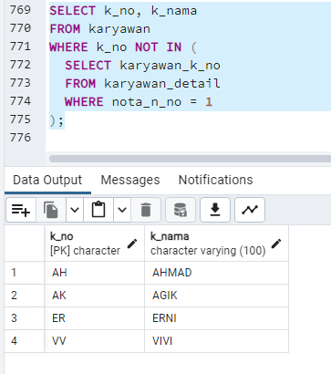

1. A screenshot of a computer

   Description automatically generated

1. 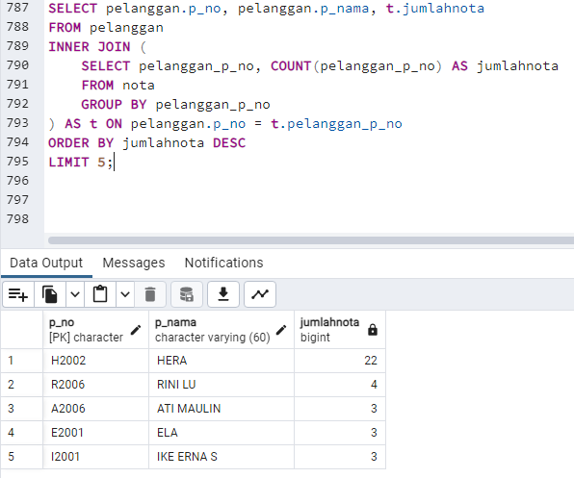

1. A screenshot of a computer

   Description automatically generated

1. A screenshot of a computer

   Description automatically generated

1. A screenshot of a computer

   Description automatically generated

1. A screenshot of a computer

   Description automatically generated
2. 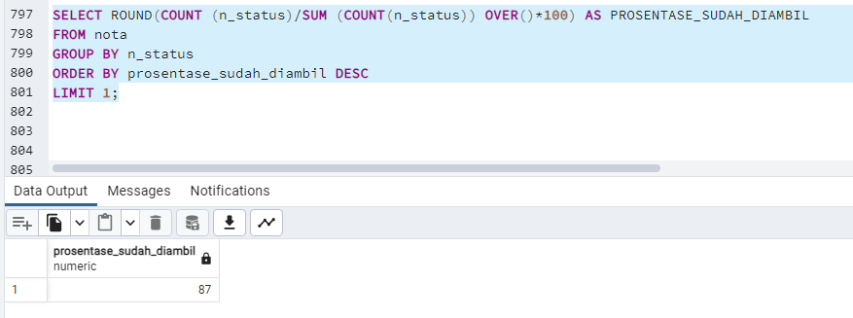

**NAME: Muhammad Rafly Abdillah**

**NRP: 5025231085**